Reference TX Chain

Purpose
This document lists the components and characteristics of the reference RF chain used by the Agentic AI Antenna-to-bits demo. It is intended to be read by the demo agent before building the MATLAB RF budget and waveform-analysis workflow.

Global Parameters
Parameter | Value
IF frequency | 4 GHz
LO frequency | 8 GHz
RF frequency | 12 GHz
Signal bandwidth | 100 MHz
Reference input power | -20 dBm
5G NR waveform | NR-FR1-TM3.1, 100 MHz, 30 kHz SCS, FDD
Baseline antenna array | 4 dipoles
Target objective | Increase EIRP above 42 dBm while keeping EVM around or below 3%

Reference Chain Components

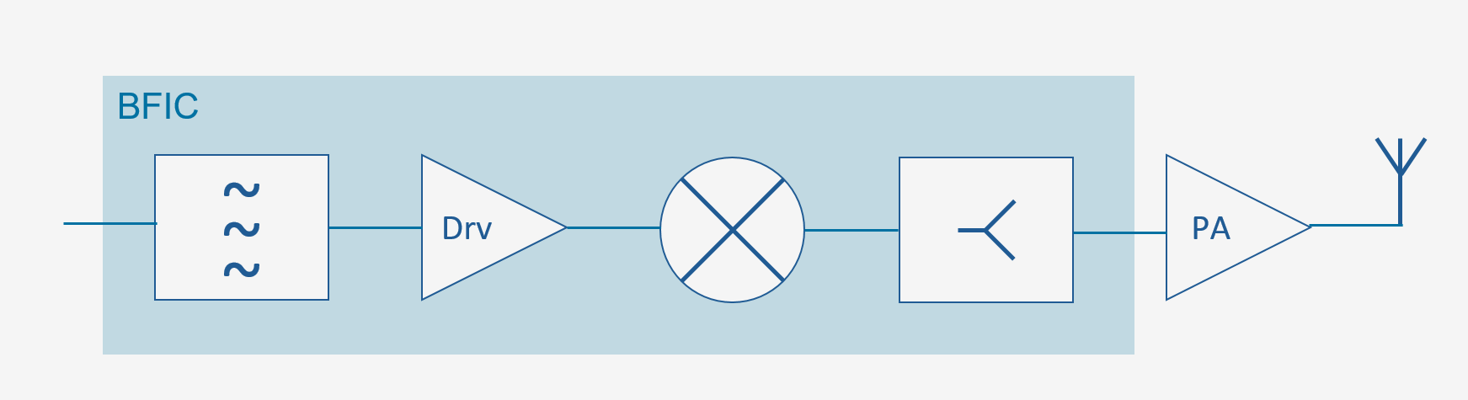
# | Component | Key characteristics | Role in chain
1 | IF filter  (BFIC #1) | - Inverse Chebyshev bandpass;  - order 5;  - passband 3.95 to 4.05 GHz;  - passband attenuation 3 dB | Removes DAC/image/spur content around the 4 GHz IF before RF conversion.
2 | Driver amplifier  (BFIC #2) | - Touchstone file CMD240withNF.s2p;  - OIP3 28 dBm;  - OP1dB 19 dBm;  - OPsat 22 dBm | Amplify the input signal, with low noise contribution.
3 | RF tuner / upconverter  (BFIC #3) | - LO 8 GHz;  - output RF 12 GHz;  - Gain 6 dB;  - NF 3 dB;  - OIP3 32 dBm | Upconverts the 4 GHz IF waveform to the 12 GHz RF carrier.
4 | Wilkinson corporate splitter  (BFIC #4) | - S-parameters data WilkinsonSplitterData  - 4-way split | Distributes the RF signal to the PA/antenna paths with realistic insertion loss and S-parameters.
5 | Power amplifier | - Gain 25 dB;  - NF 6 dB;  - OIP3 45 dBm;  - OP1dB 33 dBm;  - OPsat 37.5 dBm | Dominant EIRP driver and nonlinearity source; soft GaN compression.
6 | Antenna array | - Dipole designed at 12 GHz;  - Baseline N=4 dipoles; | Terminates the RF budget with radiating element gain/impedance for the representative path.

